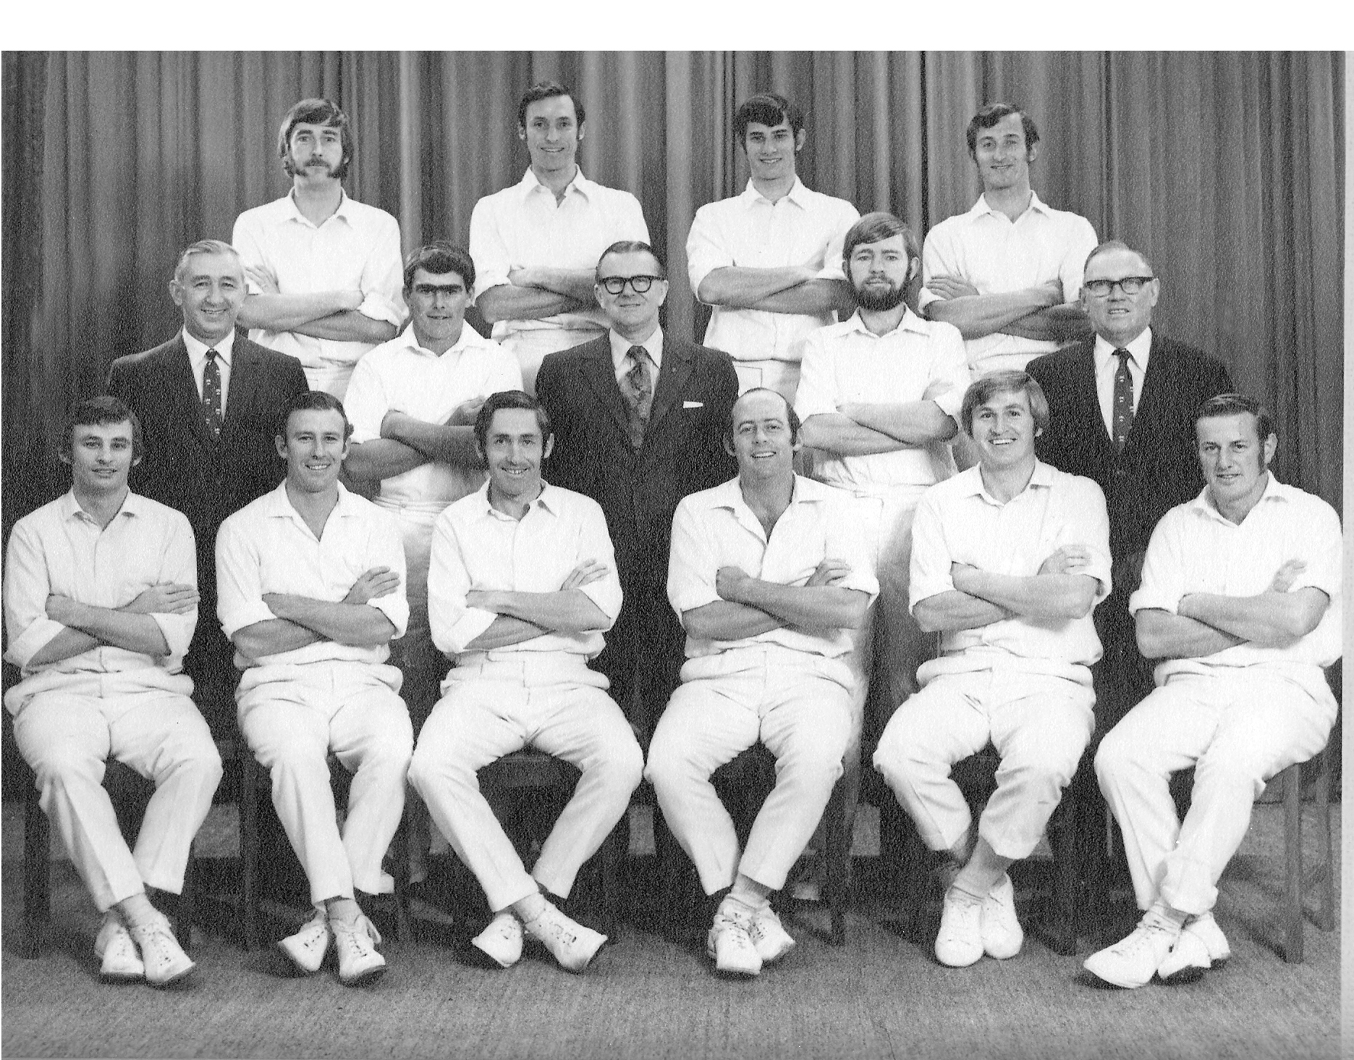

**Canterbury Representative Team 1971/72**

**Back row:** DG Trist, BG Hadlee, RJ Hadlee, DR Hadlee

**Middle row:** GW Frampton (selector), BP Isherwood, CF Collins (President), CK Baker, DN Stokes (Selector)

**Front row:** CL Bull, WJ Burtt, GT Dowling captain, BF Hastings, ML Ryan, DW Stead